The AI Engagement Agent requires two key components for generating a Work Breakdown Structure (WBS):
- The WBS template provides the overall framework and hierarchical structure of the project.
- The prompt defines the project-specific components, deliverables, and contextual requirements.
Each type of WBS therefore requires a specialized prompt tailored to the specific project file, industry standards, and project context. The following example is designed for formal municipal project governance structures, including:
- scope management
- schedule management
- cost management
- risk and contract management
- stakeholder coordination
- lessons learned
- monitoring and controlling processes
The next page presents a WBS example generated using the template structure and customized project prompt. After the framework is confirmed, several specialized prompts will be developed for different types of WBS applications and project environments.
Question and Next Steps: For each element, do we need to include a more detailed table below that provides additional information and explanations for that element?
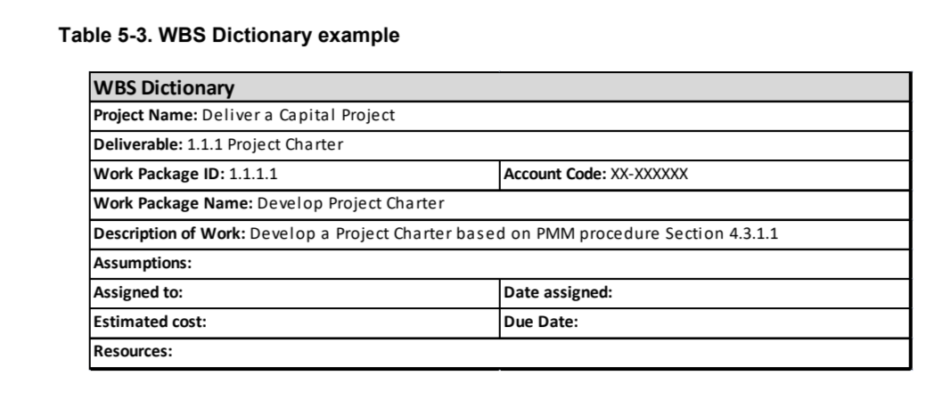

Level | WBS Code | WBS Element Title | Description / Scope of Work | Key Deliverable
1 | 1.0 | Uptown Yonge BIA Streetscape Master Plan | Complete project scope for developing a long-term streetscape vision and implementation plan for Uptown Yonge BIA. | Final Streetscape Master Plan
2 | 1.1 | Project Management | Manage project scope, schedule, communication, meetings, quality control, and coordination with the BIA and City staff. | Project management plan
3 | 1.1.1 | Project Kickoff | Confirm project objectives, study area, roles, schedule, communication process, and approval pathway. | Kickoff meeting notes
3 | 1.1.2 | Progress Coordination | Provide regular updates to the BIA Board, Streetscape Committee, Executive Director, and City Staff Working Group. | Progress meeting records
3 | 1.1.3 | QA/QC and Submission Control | Review all reports, drawings, cost estimates, and presentation materials before submission. | QA/QC checklist
2 | 1.2 | Background and Policy Review | Review existing conditions, development plans, transit plans, City policies, design guidelines, and regulatory constraints. | Background review summary
3 | 1.2.1 | Policy and Guideline Review | Review City of Toronto policies, transportation standards, public realm guidelines, accessibility requirements, and BIA-related guidance. | Policy review memo
3 | 1.2.2 | Development and Land Use Review | Identify approved or in-process developments, land use changes, nearby parks, and redevelopment opportunities. | Development inventory
3 | 1.2.3 | Transportation Context Review | Review pedestrian, cycling, transit, traffic, and parking conditions within the public right-of-way. | Transportation context summary
2 | 1.3 | Existing Conditions Inventory | Document the existing physical and visual condition of the Uptown Yonge streetscape. | Existing conditions inventory
3 | 1.3.1 | Streetscape Asset Inventory | Inventory benches, bike rings, litter/recycling bins, trees, lighting, signage, transit shelters, and BIA assets. | Streetscape asset map
3 | 1.3.2 | Visual Character and Identity Analysis | Analyze landmarks, gateways, street character, public realm quality, and district identity. | Visual character analysis
3 | 1.3.3 | Opportunities and Constraints Mapping | Map physical, regulatory, transportation, utility, and public realm constraints. | Opportunities and constraints map
2 | 1.4 | Stakeholder Engagement | Engage BIA members, local residents, community associations, City staff, and other stakeholders. | Stakeholder engagement summary
3 | 1.4.1 | Engagement Strategy | Prepare consultation approach, meeting schedule, stakeholder list, and communication materials. | Engagement plan
3 | 1.4.2 | BIA Board and Streetscape Committee Consultation | Conduct regular consultation and progress updates with the BIA Board and Streetscape Committee. | Meeting summaries
3 | 1.4.3 | City Staff Working Group Meetings | Hold at least two meetings with City staff from Transportation, Planning, Urban Design, Urban Forestry, Cycling, Vision Zero, and related divisions. | City staff meeting records
3 | 1.4.4 | Public and Community Meeting | Hold at least one public meeting with local residents and associations. | Public meeting summary
2 | 1.5 | Preliminary Assessment Report | Summarize key issues, opportunities, constraints, stakeholder input, and current environment analysis. | Preliminary assessment report
3 | 1.5.1 | Issues and Opportunities Summary | Identify major streetscape problems, business-area needs, pedestrian concerns, and design opportunities. | Issues and opportunities matrix
3 | 1.5.2 | Existing Conditions Mapping | Prepare mapping and written text showing current conditions, assets, opportunities, and constraints. | Existing conditions map package
3 | 1.5.3 | Redevelopment and Land Use Change Inventory | Document known or foreseeable property redevelopment and land use changes in the BIA. | Redevelopment inventory
2 | 1.6 | Streetscape Concept Development | Develop design concepts for key streetscape elements using drawings and visual materials. | Draft concept design package
3 | 1.6.1 | Gateway and Arrival Concepts | Design gateway features to emphasize major entry points into the Uptown Yonge BIA. | Gateway concept drawings
3 | 1.6.2 | Sidewalk and Pedestrian Pathway Concepts | Develop pedestrian realm improvements, sidewalk treatments, accessibility improvements, and pathway concepts. | Pedestrian realm concepts
3 | 1.6.3 | Lighting, Signage, and Wayfinding Concepts | Develop lighting, signage, wayfinding, and district identity elements. | Lighting/signage concept package
3 | 1.6.4 | Landscaping and Green Space Concepts | Develop tree, planting, landscape, and green infrastructure ideas. | Landscape concept plan
3 | 1.6.5 | Street Furniture and Public Art Concepts | Develop concepts for benches, trash bins, bike racks, public art, and other public realm amenities. | Street furniture/public art package
2 | 1.7 | Draft Streetscape Master Plan | Prepare draft master plan with conceptual designs, stakeholder input, and recommended improvements. | Draft Streetscape Master Plan
3 | 1.7.1 | Preferred Design Framework | Select and refine preferred design direction for the BIA streetscape. | Preferred concept plan
3 | 1.7.2 | Technical Coordination | Confirm design feasibility with City requirements, transportation needs, accessibility standards, and urban forestry considerations. | Technical coordination notes
3 | 1.7.3 | Stakeholder Review of Draft Concepts | Present draft design concepts to BIA, City staff, and community stakeholders. | Draft concept presentation
2 | 1.8 | Costing and Funding Strategy | Prepare capital cost estimates, identify possible funding sources, and evaluate implementation opportunities. | Cost estimate spreadsheet
3 | 1.8.1 | Capital Cost Estimate | Estimate capital costs for each segment of proposed work in spreadsheet format. | Capital cost spreadsheet
3 | 1.8.2 | Maintenance Cost Implications | Identify long-term maintenance requirements and cost implications for proposed improvements. | Maintenance cost summary
3 | 1.8.3 | Funding and Partnership Strategy | Identify possible City, BIA, sponsor, and partnership funding opportunities. | Funding strategy
2 | 1.9 | Implementation Plan | Develop a multi-year phased implementation strategy for short-, medium-, and long-term improvements. | Implementation plan
3 | 1.9.1 | Project Prioritization | Prioritize high-impact projects and quick-win improvements. | Priority project list
3 | 1.9.2 | Phasing Strategy | Develop time-phased implementation plan over multiple years. | Multi-year phasing plan
3 | 1.9.3 | Roles and Responsibilities | Define implementation roles for the BIA, City divisions, sponsors, and other stakeholders. | Roles and responsibilities matrix
3 | 1.9.4 | Coordination with Future City Works | Identify opportunities to bundle improvements with road, sidewalk, resurfacing, or other planned City works. | Coordination strategy
2 | 1.10 | Final Streetscape Master Plan | Finalize the report, implementation strategy, cost estimates, and presentation materials. | Final Streetscape Master Plan
3 | 1.10.1 | Final Report Preparation | Revise draft report based on comments and finalize all text, drawings, and cost information. | Final report
3 | 1.10.2 | AODA-Compliant PDF and Printed Copies | Submit electronic AODA-compliant PDF and ten printed bound colour copies. | Final submission package
3 | 1.10.3 | Final Presentation | Present the final Streetscape Master Plan to the BIA Board and stakeholders. | Final presentation materials

